Plein Aire painting: outdoors at Cabrillo Beach in the evening!
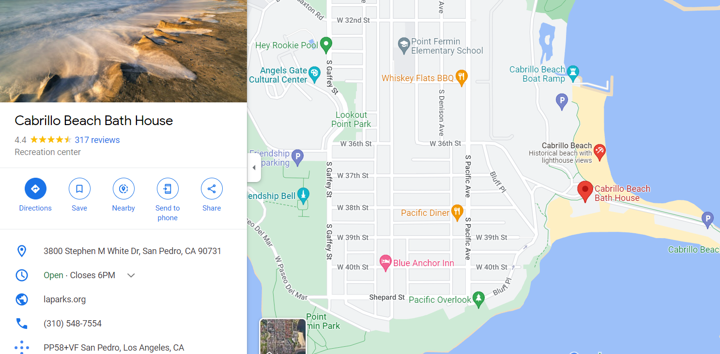
Supply list:
Pastels or oils or watercolors or acrylics, etc.
Canvas board, pastel or watercolor paper depending on the medium you choose to use.
A plein aire easel.
Paper towels, cleaning solvents, disposable gloves or barrier cream such as Art guard, bags for trash, a hat.
Heavy duty wipes like Grime Boss.
Sketch pad.
A cardboard or plastic viewfinder or we will use our two hands to block out a scene.
A plein aire umbrella if desired.
Comfortable clothing and shoes.
Refreshments - like water.

