**Watercolor Supply List _ Geoff Allen**

The most important things are good quality paper and at least one large Quill Mop, suggestions below also if you have time watch my 27 minute video on You Tube

**Paper:** 140 lb.(300gsm) 22x30” sheets, cut into 1/4 sheets, 11x15”. Expect to do at least one paintings/day (2 sheets), and two optional exercises/day, so have at least **4 plus sheets ready to go per day**.

Brands that I recommend Rough or Cold Press:

Saunders Waterford 140 lb.

Arches 140 lb.

Paper blocks, 10x14” or 12x16”

**Brushes**:

ROUNDS: Escoda Perla rounds, **#12 and #6** (or similar brands and sizes) Princeton’s Velvet touch is also nice synthetic as well.

QUILL MOPS (water shovels): You need 1-2 , a large and medium size (in painting skies, I usually use two)

My recommendations,

Synthetic Economy Brands:

* + $$ Princeton Neptune, Quill Mop Synthetic Size 6 or bigger (for wash),
  + $$$ Da Vinci Casaneo Synthetic size 4, 6 , or bigger
  + $$ Tintoretto 1412 , Goat Hair size 10, [jacksonsart.com](http://jacksonsart.com)
  + $$ Tintoretto 1407. Size 10 or 12, [jacksonsart.com](http://jacksonsart.com)

**Pencils**: 2B (.5 mm) mechanical and/or wooded and 2B-4B wooden

**Kneaded Eraser** (less abrasive)

**Paint**:

Color Suggestions. Brands I use: Daniel Smith (DS), Holbein (HWC), Winsor Newton (WN), Sennelier (S) and Cotman (less expensive). Granulates (G), You don’t have to buy everything.

**Recommended** Essential Palette:

* 1. Yellow Ochre (WN) (G)
  2. Burnt Sienna (WN) (DS-G) (HWC-D)
  3. Hansa Yellow Medium (DS)
  4. Cad Orange (WN) or Permanent Orange (DS),
  5. Organic Vermillion (DS)
  6. Alizarin Crimson Permanent (WN) (DS) or Carmine (DS)
  7. Ultramarine Blue (G)
  8. Cobalt Blue (DS or WN)
  9. Cerulean Blue (G)
  10. Phthalo Blue
  11. Royal Blue (Sennelier) or Vertider Blue (HWC)
  12. Cobalt Turquoise (DS) or Cobalt Teal (DS)
  13. Vandyke Brown (G) or Sepia (G)
  14. Neutral Tint or Ivory Black (HWC)(G)
  15. Titanium White
  16. Jaune Brilliant #1 (HWC)

**Optional** colors that you might see me use

Jaune Brilliant #2 (HWC)

Mayan Violet (DS) (G)

Raw Umber (WN) (G)

Lavender (HWC) (DS)

Brilliant Pink (HWC) (use in sky)

Alvaro’s Fresco Gray (DS)

Cobalt Violet Blue (DS)

Pyrrol Orange (DS)

Manganese Blue Nova (HWC-non granulating)

**Palette**: 16-20 color wells.

**Water Mister**: I use a recycled eye glasses spritzer. For wetting palette and paper. Wetting paper can buy you time and helps keep your paint moist on a hot day.

**Have** something to put behind your board and paper to prop up at an angle (10°-30°)

**Sketch Pad** or extra paper for sketching on, note taking. I use a 7x10” spiral pad

**Water Cup(s)** (no glass)

**Paper towels** ( I put about 14 sheets in my backpack and that is enough for the day)

**Board** - Gator Board (best, opaque and light), Signboard (flimsy), or Masonite board (heavier). I use sheet paper taped to a gator board

**Masking Tape** (avoid blue) to hold paper on board, 1/2”-1.25”

**For Plein Air**: Sunscreen, snacks, water container, hat, string or adjustable strap, Plein air easel, something to carry your materials from car to painting location (wheels are good)

**Optional Plein Air:** Portable stool, Plein air umbrella

**Art Stores** I use ( order in time, allow 10 days for delivery)

Jerry’s Artarama: <https://www.jerrysartarama.com/>

Cheap Joe’s : <https://www.cheapjoes.com/>

Blick: <https://www.dickblick.com/> (Carries Saunders Waterford Watercolor Paper, Rough, White)

Jackson Art: <https://www.jacksonsart.com/en-us/n>

**My Videos**: These are free and I go over some of the equipment that will help make you experience successful, One is about Plein air Set Up and the other is about making a shade for your set up[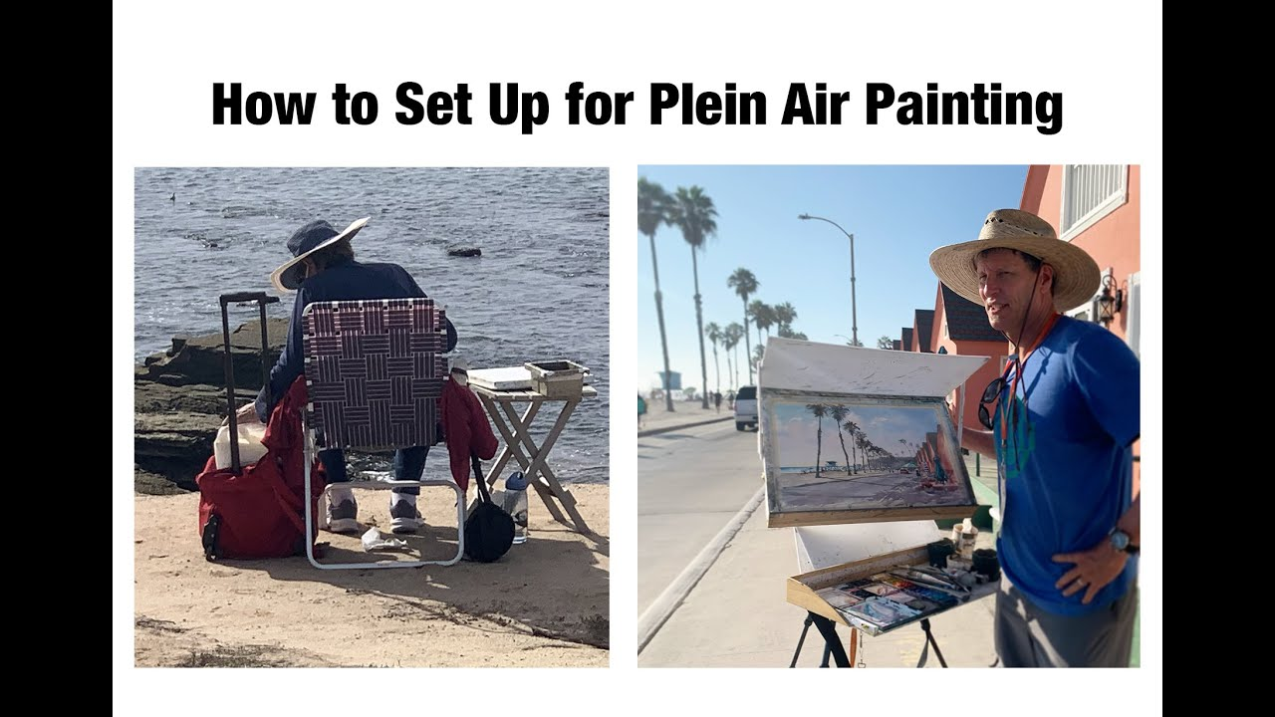](https://www.youtube.com/watch?v=Iba6ucdK3rQ)[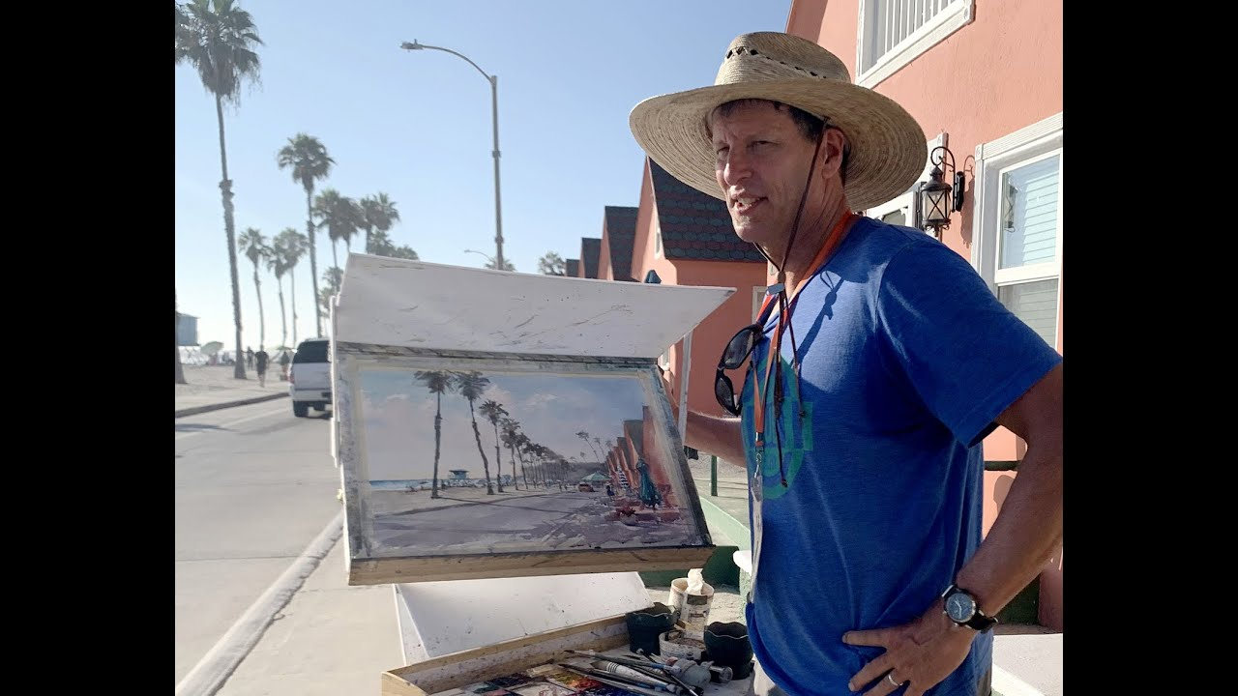](https://www.youtube.com/watch?v=4n4o4lZ97Rs)